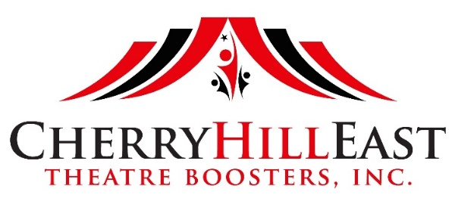
CHE Theatre Booster Membership
2021-2022

You can help support the award-winning educational theatre program at Cherry Hill High School East by joining Theatre Boosters. With membership dollars, fundraising events, and your active volunteer participation, Theatre Boosters assist the theatre department by staffing the box office, running the snack bar, providing meals during long rehearsals and much more. Cherry Hill East Theatre Boosters is a non-profit 501 (c) (3) corporation.

MEMBERSHIP LEVELS
Members receive priority access to ticket sales, meeting minutes via email, and recognition in the mainstage show programs*. Membership is valid from September through August and confers one vote.

☐ BENEFACTOR - $175.00
Additional benefits include two $5 snack bar vouchers (no cash value) to be redeemed at the Fall or Spring Mainstage productions plus one complimentary show mug from either the Fall or Spring Mainstage productions. Must be redeemed in person. A portion of your donation is tax deductible under federal tax law. See your tax advisor for details.

☐ PRODUCER - $125.00
Additional benefits include two $5 snack bar vouchers (no cash value) to be redeemed at the Fall or Spring Mainstage productions. A portion of your donation is tax deductible under federal tax law. See your tax advisor for details.

☐ DIRECTOR - $75.00
Additional benefits include one $5 snack bar vouchers (no cash value) to be redeemed at the Fall or Spring Mainstage productions. A portion of your donation is tax deductible under federal tax law. See your tax advisor for details.

☐ ACTOR - $50.00
A portion of your donation is tax deductible under federal tax law. See your tax advisor for details.

Name (*as you would like it to appear in Mainstage show programs):

Email: Phone:

Student: Grade: Cast: ☐ Crew: ☐ Both: ☐

Student: Grade: Cast: ☐ Crew: ☐ Both: ☐

Address:

☐ FRIEND - $25.00 *NON-MEMBER STATUS*
NON-MEMBER/NON-VOTING STATUS CATEGORY. It is perfect for alumni, grandparents, parents of alumni, faculty, and community supporters interested in helping the Theatre Program at Cherry Hill East. A portion of your donation is tax deductible under federal tax law. See your tax advisor for details.

Make checks payable to CHHSE Theatre Boosters. Please mail this form to:
Leslie Hornstein, CHETB Membership
1036 Red Oak Drive
Cherry Hill, NJ 08003

Interested in learning more about CHHSE Theatre Boosters? Visit us at: chetb.weebly.com.

